MacArthur Park 5K 2019 Dog T-Shirt Order Form
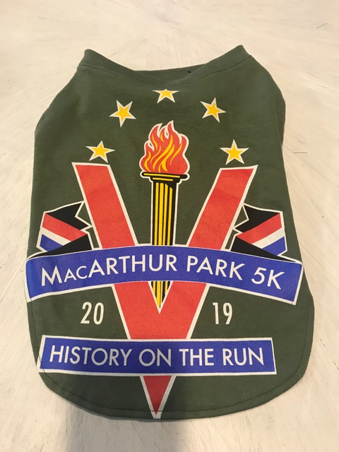

Name: _____________________________________
Phone Number: (______) ______________________
Address: ____________________________________
City: __________________ State: _______________
Zip Code: ______________
Size: M L Payment Type:
Credit Card
*Checks should be made payable to Check
Downtown Little Rock Partnership with Cash
Memo noting: MacArthur Park Group.
*Payment must be received with order.

